**Lesson: Connecting Surveys, Maps, and Apps: Creating and Analyzing field data in a Survey, Map, Dashboard, and Story Map**

Connecting components of modern GIS, including field surveys, dashboards, interactive maps, and multimedia maps, can help foster spatial thinking, critical thinking, and rigorous use of GIS tools and data. This lesson guides you through the creation of a survey in Survey123, mapping the resulting data in ArcGIS Online, creating and using a Dashboard, and creating a story map.

This lesson will focus on walkability, but the same concepts can be used for any theme, from local to global—pedestrian and vehicle counts, water quality, weather observations, housing or business type, zoning, light poles, recycling bins, invasive species, litter, and other features or issues in the natural or built landscape.

**Requirements for this lesson: (1)** An ArcGIS Online account in which you have the User Type of Creator and the Role of Publisher. **(2)**  The zip file associated with this lesson, which contains photographs and this lesson in PDF and in DOCX formats.

**This lesson is organized in 4 parts:   
Part 1: Creating a field survey using Survey123.**

**Part 2: Creating and analyzing a map from your survey data.**

**Part 3: Creating a dashboard from your survey data.**

**Part 4: Creating a storymap from your field data.**

**Part 1: Creating a field survey using Survey123.**

A survey will allow you and others to collect data about an issue, theme, or situation, on a mobile device in the field or via a web browser on a computer.

[1a]. Go to <https://survey123.arcgis.com> > Sign in with your ArcGIS Online account (again, in which you have the User Type of Creator and the Role as Publisher).

[1b]. Create a new survey > Use the web designer > Get Started > Provide some metadata (name, tags, summary): Walkability Survey | Walkability, pedestrians, smart cities | A survey to assess if and how different areas in a community are walkable. > Create.

[1c]. Design the survey.

(1) Add question #1: Multiple Choice: Pedestrian Friendly or Unfriendly? Create 2 choices: Pedestrian Friendly, and Pedestrian Unfriendly. Make 2 choices only. Make this a required question. > Save.

(2) Add question #2: Likert. Label: Rate the walkability of this site. For “items” indicate: Horrible for pedestrians, Not ideal for pedestrians, Neutral, Good for pedestrians, Excellent for Pedestrians. > Save. (3) Add question #3: Multiple Choice: Label: Tick all characteristics that describe the site: Dedicated path or sidewalk, Wide path or sidewalk, Poor surface condition, Dangerous cross traffic, No path or sidewalk, Obstructions: Branches, snow, etc., Unsafe. 7 characteristics total. Do not allow “Other”. > Save.

(4) Add question #4: Geopoint. Label: Where is the site located? Set Default Map to “OpenStreetMap”. Tick “Ask for device’s location when opening this question.” For the map’s location, search for your community and set the scale and location where you anticipating you collecting the most data. > Save.

(5) Add question #5: Image. Label: Submit a photograph of the site. > Save. Your survey should look similar to this, below:

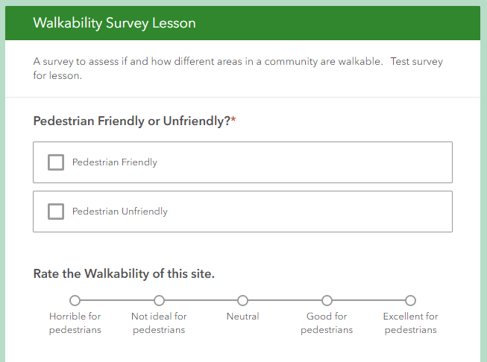

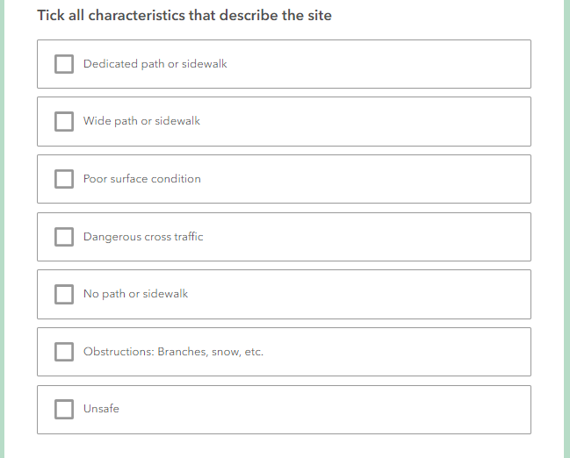

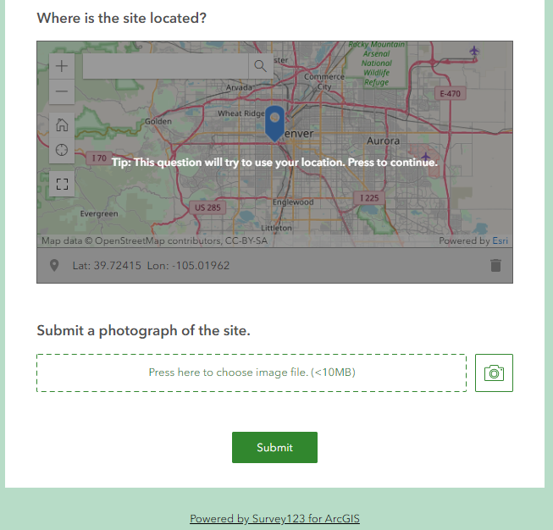

[1d]. Preview the survey. Close. If necessary, make adjustments to your survey. When satisfied, > Publish. Go to Collaborate tab in survey > Tick: Ask the user how to open the survey, in browser or in the survey123 field app. Then, under “who can submit to this survey?” share at least with your organization, or groups within your organization. Under “What can submitters do?”, tick “add and update records”. Before leaving this screen, copy the “arcg.is” link near the top of the Collaborate page under “Link.” Example: <https://arcg.is/0z1vfu>. At bottom of screen > Save.

**Part 2: Creating and analyzing a map from your survey data.**

A map will allow you and others to visualize your survey data, showing patterns and relationships, and allow you to perform spatial analysis.

[2a]. Your survey has been created with an editable feature survey within it. Test it by opening the URL you copied above, and open your survey in a browser. Add at least 1 pedestrian friendly entry in your survey with a photo and a location, and 1 pedestrian unfriendly entry with a photo and a location, making certain that everything is working as you intended. You can use your own photos or the ones the author of this lesson has provided in the zip file. If you use the latter, the Evergreen Colorado pedestrian friendly photo is located at the following latitude longitude coordinate: 39.624631, -105.322921 with a rating of “Good for pedestrians” and characteristics of “Dedicated path or sidewalk” and “Obstructions: Branches, snow, etc.”. The Lakewood Colorado #1 pedestrian **un**friendly photo is located at the following latitude longitude coordinate: 39.708678, -105.110154 with a rating of “Not ideal for pedestrians” and a characteristic of “Dangerous cross traffic.” The Lakewood Colorado #2 pedestrian **un**friendly photo is located at the following latitude longitude coordinate: 39.712871, -105.102729 with a rating of “Not ideal for pedestrians” and a characteristic of “No path or sidewalk.”

When done filling out the survey, click on the Data tab at the top of the survey and verify that your point was added to the map.

[2b]. Open a new browser tab > Go to [www.arcgis.com](http://www.arcgis.com) > Sign in > Go to Content, My Content. In list of folders on left, find the folder (beginning with “Survey” in the title) with your new survey. This folder will contain a form, a feature layer (hosted, view), and another feature layer (hosted). Click on feature layer (hosted) and examine the metadata. Fill in the summary and description as “Walkability survey feature layer.” > In upper right, Open in Map Viewer. Pan and zoom the map to your study area. Verify that your added point exists. If desired, change basemap to another of your choice. Change style to Pedestrian Friendly or Unfriendly. Under Options > Unique Symbols, choose symbols that contrast with each other. Note: There may be some delay before you see your points on your map. Save your map and provide some metadata. Share your map with everyone. Copy the resulting URL.

[2c]. With your URL copied, go back to the tab containing your survey design form. > Design > Settings > Thank You Screen > Edit the text under the check box, so that it reads: Excellent! Your data was sent successfully. If you wish, see the point on this interactive web map! Now get walking! For the text “see this point on this interactive web map”, click on the Link symbol and for the link paste the URL of your map. Save > Preview > Publish. If you wish, add another point to your survey and make certain the ‘end screen’ has been saved and that the link points to your web map.

At this point, your web map will have a similar appearance to the map below. The author used “Add Data” and added the Modern Antique base map for a unique base map experience.

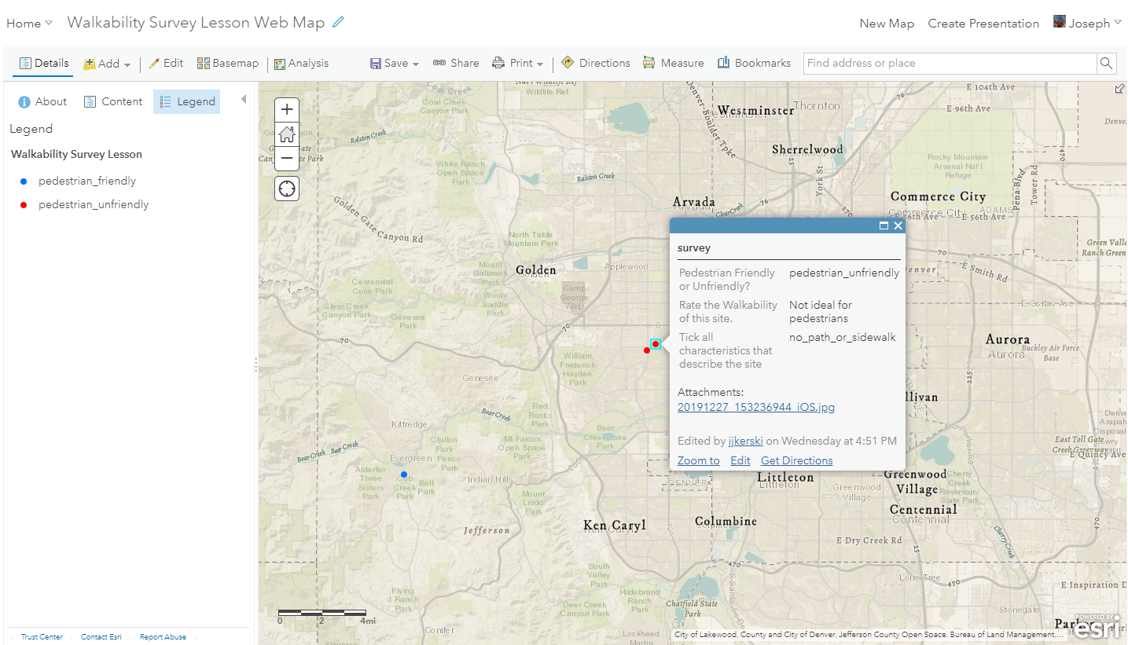

**Part 3: Creating a dashboard from your survey data.**

A dashboard allows you and others to quickly visualize your survey results in a series of maps and graphs.

[3a]. While viewing your web map, > Share > Create a web app > Dashboard. Provide a title such as Walkability Survey Dashboard. Tick “share this app in the same way as the map.” > Done.

[3b]. Edit your dashboard. Use + sign > Pie chart > Select Walkability survey > Grouped Values > Pedestrian Friendly or Unfriendly? Take default colors. Use + sign > Add another pie chart > Select walkability survey > Grouped Value > Rate the walkability of this site. Use + sign > Add map legend. Use + sign > Add gauge. Use + sign > add image. If you need an image, you can use the author’s image on: <https://live.staticflickr.com/7805/33263417808_640912b3bf_w.jpg>. Adjust the size, placement, and add titles to the elements in your dashboard. An example of what your dashboard could look like is below:

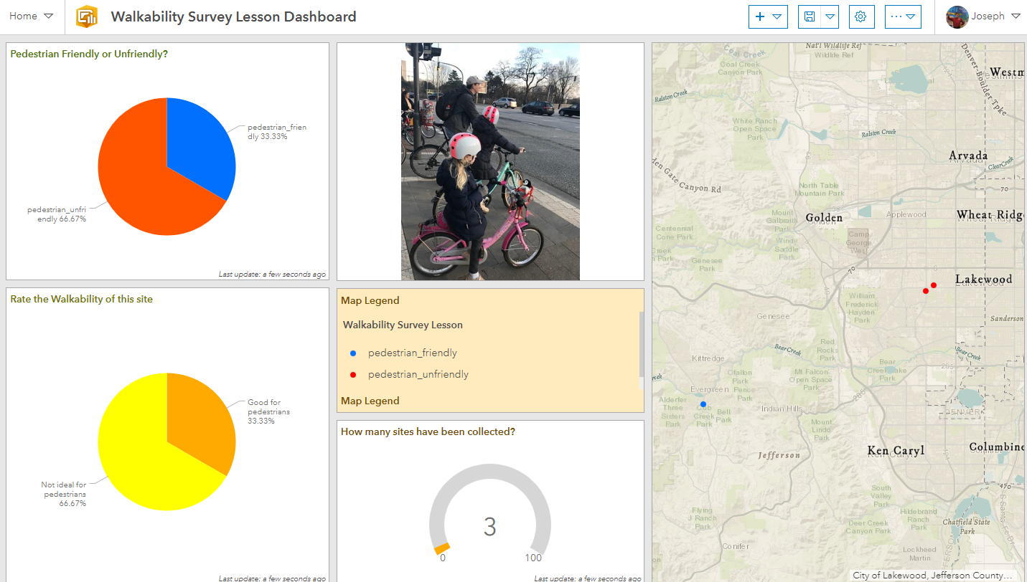

**Part 4: Creating a storymap from your field data.**

A storymap allows you, with multimedia and interactive web maps, to tell the story about the problem you are studying, along with possible solutions.

[4a]. Go to: <https://storymaps.arcgis.com> > Sign in. This activity uses the new storymaps (not the “classic” storymaps). You should now be here:

<https://www.esri.com/en-us/arcgis/products/arcgis-storymaps/overview>

Once you are signed into your ArcGIS Online account > Create New Story, as shown below:

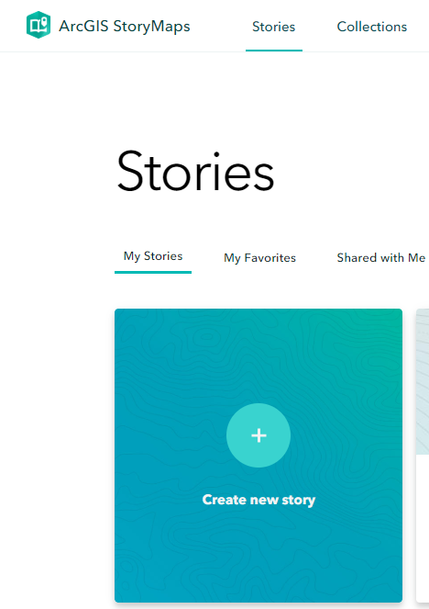

[4b]. Insert the following items into your story map.

**[Title]  
How walkable is your community?**

**[Subtitle]**

A survey and map showing the degree of pedestrian friendliness of your community.

**[Cover image: Lakewood Photograph #1 or your own photo.]**

**[Byline]**

By < your initials >| Today’s Date

**[Quote]**

*“The General Theory of Walkability explains how, to be favored, a walk has to satisfy four main conditions: it must be useful, safe, comfortable, and interesting.”*

*― Jeff Speck, Walkable City: How Downtown Can Save America, One Step at a Time.*

**[Paragraph]**

Walkability is the degree to which pedestrians, including those in wheelchairs, on bicycles, scooters, and in any other non-vehicle mode, feel safe and able to traverse their community. Whether one wants to walk in a community depends on many factors, such as social norms, safety, personal preferences, and other factors. This study focuses on the physical challenges or lack of challenges that pedestrians face. For pedestrians using wheelchairs or pushing strollers, walkability can also be influenced by curb cuts, stairs, or obstacles on the sidewalk.

**[Paragraph]**

What is the walkability on a street or path in your own community? Submit your own point using the link below:

**[Button]**

Text in button: **Click to Submit Survey Point.**

Link in button: Find the URL for your Survey123 about walkability and insert it here. Or, use the author’s survey here: <https://arcg.is/1nKevj>

**[Paragraph]**

The results of this survey, with data gathered from pedestrians around the world, can be visualized on the map below.

**[Map]**

Open a separate tab in your browser and go to [www.arcgis.com](http://www.arcgis.com) > Sign in if necessary > search for your ArcGIS Online map showing the results of your walkability survey. Once you find the map, under the thumbnail, click “Add to Favorites.” Or, use the author’s web map, here: <http://www.arcgis.com/home/webmap/viewer.html?webmap=f2c79a4332be488fb15a2254a3bf901e>

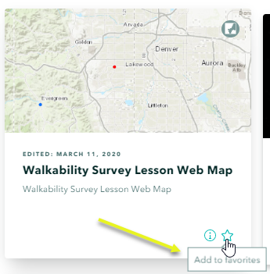

Go back to your browser tab where you are editing your story map.

**[Map]**

> My favorites > select the walkability map, which should now appear in your favorites from the previous step. Zoom in to the largest scale such that all 3 walkability survey points are visible > Place Map.

Overwrite the default caption with the following text: Map showing walkability survey points. Your map should look like this, below. Your users will be able to interact with it.

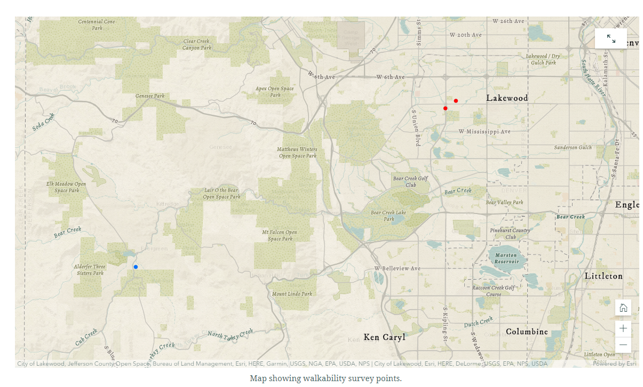

At the top of your story map, check to make sure your story map that you are creating is auto-saving and is in draft. It should be! But always a good idea to check.

**[Embed]**

Add a link to your Dashboard. Or use the author’s dashboard: <https://www.arcgis.com/apps/opsdashboard/index.html#/f4e5ce79b4bb4ffc8b29e1c73629bfce>

Change the dashboard caption to: Walkability survey responses.

When done, the dashboard should be embedded into your storymap, as shown below. Your users will be able to interact with it.

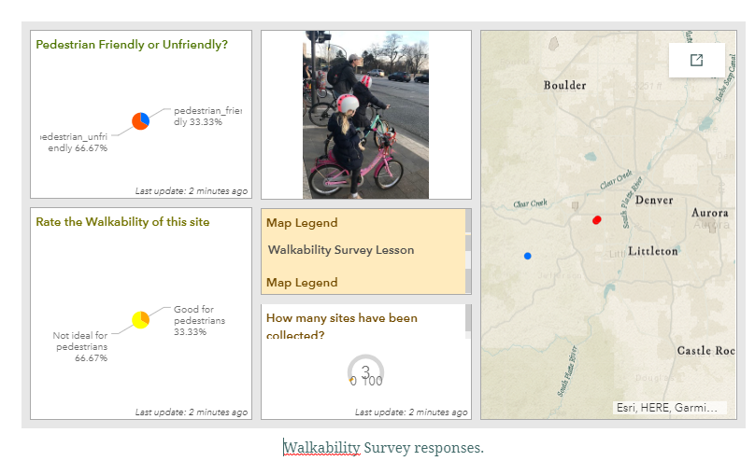

[**Heading**]

Would you say the following location is walkable?

[**image**]

Use the Lakewood Colorado #1 image (or your own image).

[**Heading**]

Would you say the following location is walkable?

[**image**]

Use the Lakewood Colorado image #1 (or your own image).

**[Video]**

Add “Walking in a Pedestrian Unfriendly Place” video in New Jersey by the author, Joseph Kerski at this URL: <https://youtu.be/wEmZiDv7BjM> The video should appear as embedded content in your story map, as shown below:

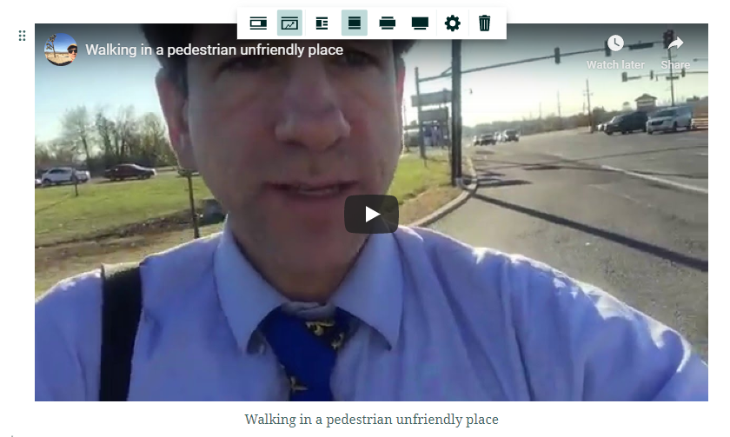

**[Separator]**

[**Paragraph**]

Story Map by < your initials > using lesson provided by Joseph Kerski, Esri, as an introduction to Survey123, web maps, operations dashboards, and story maps.

[**Separator**]

[4c]. When satisfied, preview your story map, test it, publish, and share. The author’s story map is here: <https://storymaps.arcgis.com/stories/7afc60296c424214b0be2221232a8346>

Congratulations on your good work! Consider sharing your story map with others in your organization or beyond so they can see your good work. ●